GENERATIVE AI
Generative AI (Artificial Intelligence) is a type of AI that can create new content such as text, images, music, videos, and computer code by learning patterns from large amounts of existing data.
Unlike traditional AI, which mainly analyzes data or makes predictions, generative AI can generate original outputs that resemble human-created content.
At the core of generative AI are advanced machine learning models, particularly Large Language Models (LLMs) and deep neural networks. These models are trained on vast amounts of data and learn how different pieces of information relate to one another. Once trained, they can produce new outputs that are often difficult to distinguish from content created by humans.
One of the most significant breakthroughs in generative AI is its ability to understand and respond to natural language. Tools such as chatbots and AI assistants can answer questions, summarize documents, draft emails, create reports, and even assist with complex problem-solving. In addition to text generation, modern generative AI systems can create realistic artwork, compose music, generate videos, and write software code from simple instructions.
As AI models continue to improve, generative AI is expected to become an integral part of everyday life and work. Rather than replacing humans, it is often viewed as a powerful tool that augments human creativity, productivity, and decision-making. Its ability to generate content, solve problems, and assist users interactively makes it one of the most influential technological advancements of the modern era.
Generative AI is trained on vast datasets and uses advanced machine learning models, particularly Large Language Models (LLMs) and deep learning neural networks, to understand patterns and produce new content.

Types of Generative AI
Generative AI systems are designed to create different forms of content. Depending on the type of data they process and generate, they can be classified into several categories.
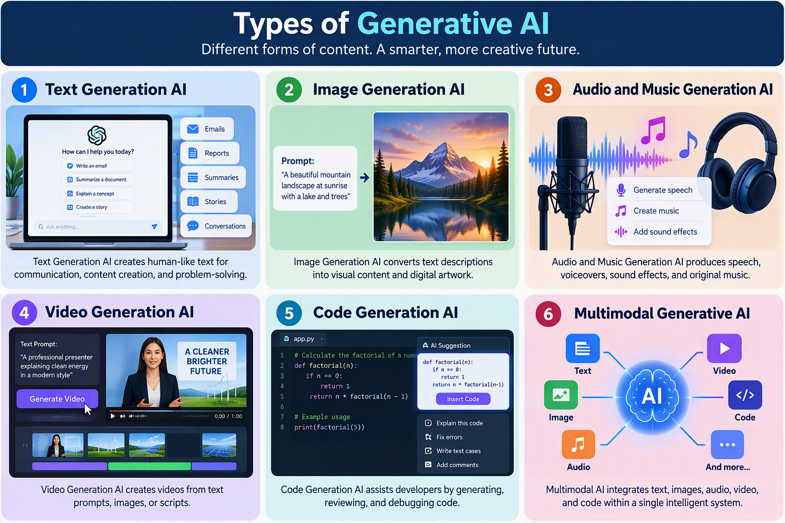

1. Text Generation AI
Text generation models produce human-like written content. They understand natural language and can generate responses, articles, summaries, stories, reports, and even conversations. These systems are trained on massive collections of text and learn patterns in language, grammar, and context.
Examples: ChatGPT, Microsoft Copilot, Gemini
Applications:
- Content creation
- Email drafting
- Chatbots and virtual assistants
- Language translation
- Document summarization

2. Image Generation AI
Image generation models create new images based on text prompts or other visual inputs. Users can describe a scene in natural language, and the AI generates a corresponding image. These models are widely used in design, advertising, and digital art.
Examples: DALL·E, Midjourney, Stable Diffusion
Applications:
- Graphic design
- Marketing materials
- Product visualization
- Art and creative projects
- Image enhancement and editing

3. Audio and Music Generation AI
These systems generate speech, music, sound effects, or voice recordings. They can mimic human voices, compose original music, and convert text into natural-sounding speech.
Examples: ElevenLabs, Suno AI, MusicLM
Applications:
- Audiobook narration
- Podcast production
- Voice assistants
- Music composition
- Accessibility tools

4. Video Generation AI
Video generation AI creates videos from text descriptions, images, or scripts. It can generate animations, realistic scenes, and even virtual presenters. This technology is rapidly evolving and is becoming increasingly important in content creation.
Examples: Sora, Runway, Synthesia
Applications:
- Educational videos
- Marketing campaigns
- Employee training
- Social media content
- Film and animation production

5. Code Generation AI
Code generation models assist software developers by generating, reviewing, and explaining programming code. They can suggest code snippets, identify errors, and help automate repetitive development tasks.
Examples: GitHub Copilot, Microsoft Copilot, Amazon CodeWhisperer
Applications:
- Software development
- Code debugging
- Test case generation
- Documentation creation
- Learning programming languages

6. Multimodal Generative AI
Mjkjjultimodal AI combines multiple forms of data, such as text, images, audio, and video, within a single system. These models can understand information from different sources and generate outputs across various media formats.
For example, a multimodal AI can analyze an image, answer questions about it, and then generate a written summary or a related image.
Examples: GPT-4o, Microsoft Copilot, Gemini
Applications:
- Intelligent digital assistants
- Interactive learning systems
- Content creation platforms
- Advanced search and analysis
- Human-computer interaction

